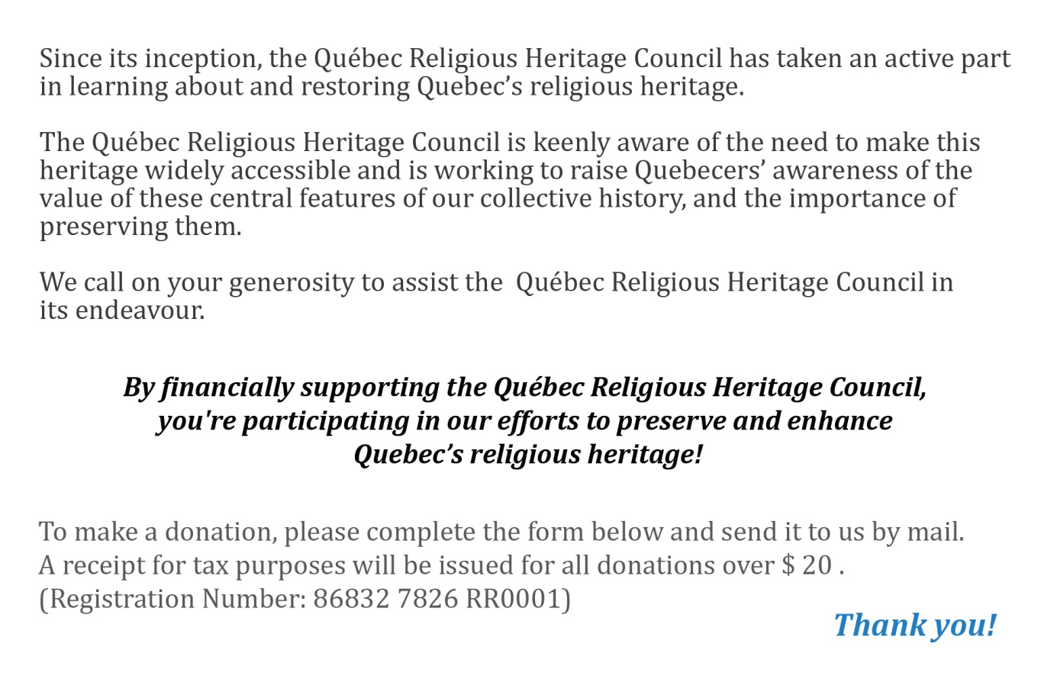

IDENTIFICATION OF DONOR
First Name
Name
Title
Organism/Company
Address
Phone
Email

DON
It is my pleasure to donate  To  the Council the amount of: | $

Please make your check payable to the Québec Religious Heritage Council and send it, along with the form, to the address below:

