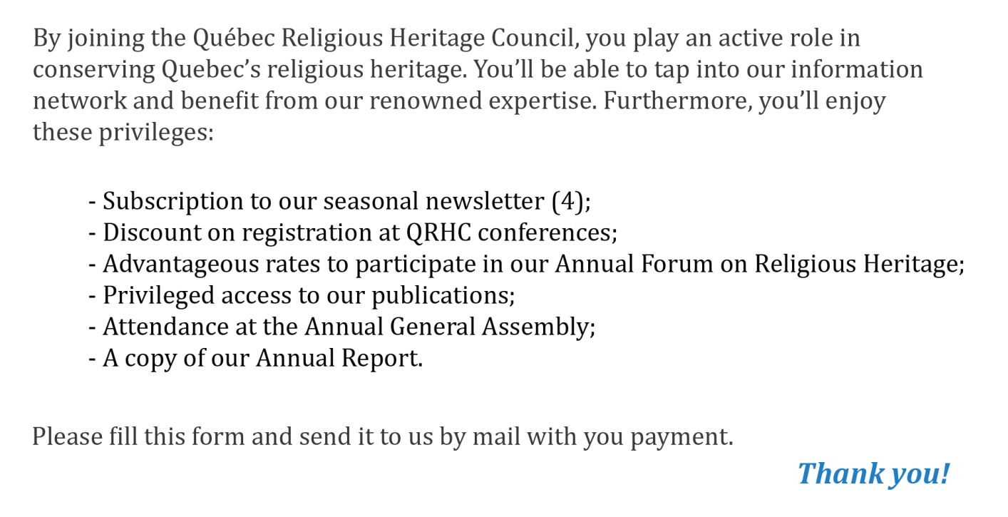

IDENTIFICATION
First Name
Name
Title
Organism/Company
Address
Phone
Email

MEMBERSHIP
Renewal?
Individual subscription ($25)
Corporative subscription ($100)

Please make your check payable to the Québec Religious Heritage Council and send it, along with the form, to the address below:

